Evaluating Classical Machine Learning Models for Topic Classification in High-Dimensional Text: A Comparative Study on the TopicNet/HuggingFace 20 Newsgroups Dataset
Hari kuruvagantela
student id 16119961
Faculty of Data Science
Coventry University
Coventry,England
kuruvaganh@coventry.ac.uk

Abstract-This research evaluates the efficacy of three machine learning algorithms—Linear Support Vector Machine, Logistic Regression, and Multinomial Naïve Bayes—utilizing the 20 Newsgroups dataset from TopicNet/HuggingFace. In TF-IDF research on text documents, TruncatedSVD was employed to make the data less complex. The best models are LinearSVC and Logistic Regression, but their accuracy (around 70%) is substantially lower than the usual benchmarks, as shown by the original Sklearn dataset. Naïve Bayes did well in competitions, but not as well as it could have because it trained faster. TruncatedSVD made the models smaller and trained them faster, but it also made all of them work a little less well. These results illustrate that the way you preprocess your dataset and the version of the corpus you use have a big effect on how your model works. Even though its accuracy is going down, LinearSVC is still the best traditional method for categorizing topics in high-dimensional sparse text.

Keywords
Text classification, 20 Newsgroups, Linear SVM, Logistic Regression, Multinomial Naive Bayes, Dimensionality reduction, TruncatedSVD, TF-IDF.
Link .https://huggingface.co/datasets/TopicNet/20-Newsgroups
- Introduction
Automated topic classification supports document organization, content delivery, moderation, and search optimization. The 20 Newsgroups dataset, with its diverse topics and lexical variability, remains a standard benchmark for text classification. Performance can vary with corpus versions and preprocessing; the TopicNet/HuggingFace variant differs from the sklearn distribution in formatting, metadata, and text cleanliness.
Classical machine learning methods with TF-IDF features—Linear SVM, Logistic Regression, and Multinomial Naïve Bayes—remain efficient, interpretable, and competitive alternatives to neural models. This study evaluates these classifiers on high-dimensional TF-IDF features, with and without TruncatedSVD dimensionality reduction. On the TopicNet/HF dataset, models achieve 67%–71% accuracy, lower than prior benchmarks (~80%), highlighting the impact of dataset and preprocessing variations. The goal is to provide an updated, transparent assessment of classical models and the effects of dimensionality reduction for practical topic classification.
- Problem Statement and Dataset Description

Problem Statement
Automated topic categorization is a key task in natural language processing that categorizes text documents by content. In this work, multi-class classification is used to predict one of the 20 Newsgroups dataset thematic categories from an input item. These categories cover politics, sports, religion, technology, and automobiles.
Topic classification matters in practice. This allows efficient document management, content filtering, tailored information retrieval, and automatic online platform moderation. Linear Support Vector Machines (LinearSVC), Logistic Regression, and Multinomial Naive Bayes remain computationally efficient, interpretable, and frequently used baselines in high-dimensional text spaces like those formed by TF-IDF vectorization. Academic research and real-world implementation require understanding how these models perform on modern datasets and how dimensionality reduction affects them.
- Our work aims to examine the accuracy, macro-F1 score, training duration, and computing efficiency of LinearSVC, Logistic Regression, and Multinomial Naive Bayes on high-dimensional text data.
- Assess the impact of TruncatedSVD dimensionality reduction on model performance.
- Explore performance, efficiency, and interpretability trade-offs to assist practitioners in choosing appropriate models for real-world subject classification.
- Dataset Description
The experiments use the 20 Newsgroups dataset, a benchmark for multi-class text classification with ~18,000 newsgroup posts across 20 topics. Each document is raw text, often containing headers and signatures.
Key characteristics:
- Training/Test Split: ~11,000 training and 7,000 test documents.
- High Dimensionality: TF-IDF vectorization produces tens of thousands of sparse features.
- Preprocessing: Lowercasing, tokenization into unigrams and bigrams, stop-word removal, filtering rare/common terms (min_df=3, max_df=0.9), and sublinear TF scaling.
This study uses the TopicNet/HuggingFace variant, which differs slightly from the original sklearn distribution in formatting and text cleanliness, providing a modernized testbed for evaluating classical machine learning algorithms.
- Methods

1. Feature Extraction
Text is represented using TF-IDF, capturing term importance while controlling for extreme frequencies. Configuration: unigrams + bigrams, min_df=3, max_df=0.9, sublinear TF scaling, and English stop-word removal.

2. Dimensionality Reduction
TruncatedSVD compresses TF-IDF vectors into 300 components, reducing memory and computational requirements while retaining most variance. This allows analysis of efficiency-performance trade-offs.

3. Machine Learning Models
Three classical algorithms are evaluated:
- LinearSVC: Finds optimal separating hyperplanes; efficient for high-dimensional sparse data; L2 regularization, C ∈ {0.1, 1, 10}, max_iter=5000.
- Logistic Regression (One-vs-Rest): Estimates class probabilities, interpretable coefficients; L2 regularization, C ∈ {0.1, 1, 10}, solver liblinear or saga.
- Multinomial Naive Bayes (MNB): Probabilistic model for word counts; extremely fast; smoothing alpha ∈ {0.1, 0.5, 1.0}.

4. Evaluation Metrics
- Accuracy and macro-averaged F1 (handles class imbalance)
- Macro-averaged precision and recall
- Training time for computational efficiency

5. Experimental Protocol
- Preprocessing and feature extraction are fit on training data only.
- Models are trained on both full TF-IDF and SVD-reduced embeddings.
- 5-fold cross-validation is used for hyperparameter tuning.
- Random seeds fixed for reproducibility (random_state=42).
This setup allows a rigorous, reproducible comparison of classical models in terms of accuracy, efficiency, and interpretability for topic classification.

Experimental Setup
This section details the experimental design used to evaluate classical machine learning models on the TopicNet/HuggingFace 20 Newsgroups dataset. The setup ensures rigorous, reproducible, and fair comparisons across models and configurations.

1. Data Splitting
The dataset follows the canonical train–test split:
- Training set: 11,083 documents
- Test set: 7,370 documents
All preprocessing, feature extraction, and model training are performed exclusively on the training set, with transformations applied to the test set using transform operations. This prevents information leakage and ensures unbiased evaluation.

2. Data Preprocessing
Raw text documents contain headers, signatures, and email metadata. Preprocessing steps include:
- Lowercasing – to reduce sparsity caused by inconsistent casing.
- Tokenization – splitting text into words using the default scikit-learn tokenizer.
- Stop-word removal – excluding common English words that contribute little to classification.
- Filtering rare and frequent terms:
  - min_df=3 (removes extremely rare words)
  - max_df=0.9 (removes overly common words)
- Sublinear TF scaling – dampens the effect of long documents.
- N-gram inclusion – unigrams and bigrams (ngram_range=(1,2)) to capture contextual information.
This pipeline balances vocabulary richness with computational efficiency.

3. Feature Extraction
- TF-IDF Vectorization:
Converts text into high-dimensional sparse matrices capturing term importance relative to document frequency.
  - norm='l2' for linear classifiers
  - sublinear_tf=True
  - Vocabulary size: 50,000–70,000 features
- Dimensionality Reduction:
Truncated Singular Value Decomposition (TruncatedSVD) is optionally applied to reduce TF-IDF vectors to 300 components, producing dense embeddings.
  - Retains most semantic variance
  - Reduces memory usage and computational cost
  - Compatible with sparse matrices
- Visualization:
A 2D PCA projection is generated on a sample of 500 SVD-transformed points for topic clustering visualization.

4. Classification Parameters
Three classical models are evaluated with hyperparameter tuning using 5-fold cross-validation:
- Linear Support Vector Machine (LinearSVC)
  - Penalty: L2
  - Regularization parameter C ∈ {0.1, 1, 10}
  - Maximum iterations: max_iter=5000
- Logistic Regression (One-vs-Rest)
  - Solver: liblinear for sparse TF-IDF, saga for SVD features
  - Regularization parameter C ∈ {0.1, 1, 10}
  - Maximum iterations: max_iter=2000
- Multinomial Naive Bayes (MNB)
  - Smoothing parameter alpha ∈ {0.1, 0.5, 1.0}
Models are trained on both full TF-IDF vectors and SVD-reduced embeddings to assess the trade-offs between accuracy, efficiency, and storage requirements.

5. Evaluation Metrics
Performance is measured using:
- Accuracy – proportion of correct predictions
- Macro F1-score – averages F1 across classes, mitigating class imbalance
- Macro Precision & Recall – evaluate predictive quality across all categories
- Training Time – quantifies computational efficiency
All experiments are executed with fixed random seeds (random_state=42) for reproducibility, and results are logged along with trained model artifacts and visualizations.
- Results
The experimental evaluation compared the performance of three classical machine learning models—LinearSVC, Logistic Regression (One-vs-Rest), and Multinomial Naive Bayes—on the TopicNet/HuggingFace 20 Newsgroups dataset. Models were assessed using full TF-IDF features and TruncatedSVD-reduced embeddings (300 components). Key metrics include accuracy, macro-F1 score, and training time.

1. Full TF-IDF Features
Model | Accuracy | Macro-F1 | Training Time (s)
LinearSVC | 0.7088 | 0.6959 | 1.25
Logistic Regression | 0.7079 | 0.6898 | 2.40
Multinomial Naive Bayes | 0.6913 | 0.6616 | 0.06
Observations:
- LinearSVC achieved the highest accuracy and macro-F1, confirming its effectiveness in high-dimensional sparse spaces.
- Logistic Regression performed competitively and provides interpretable coefficients for each class.
- Multinomial Naive Bayes was fastest to train but slightly less accurate, highlighting its suitability for time-sensitive applications.

Training LinearSVC...
LinearSVC | Accuracy: 0.7088 | F1: 0.6959 | Time: 1.25s
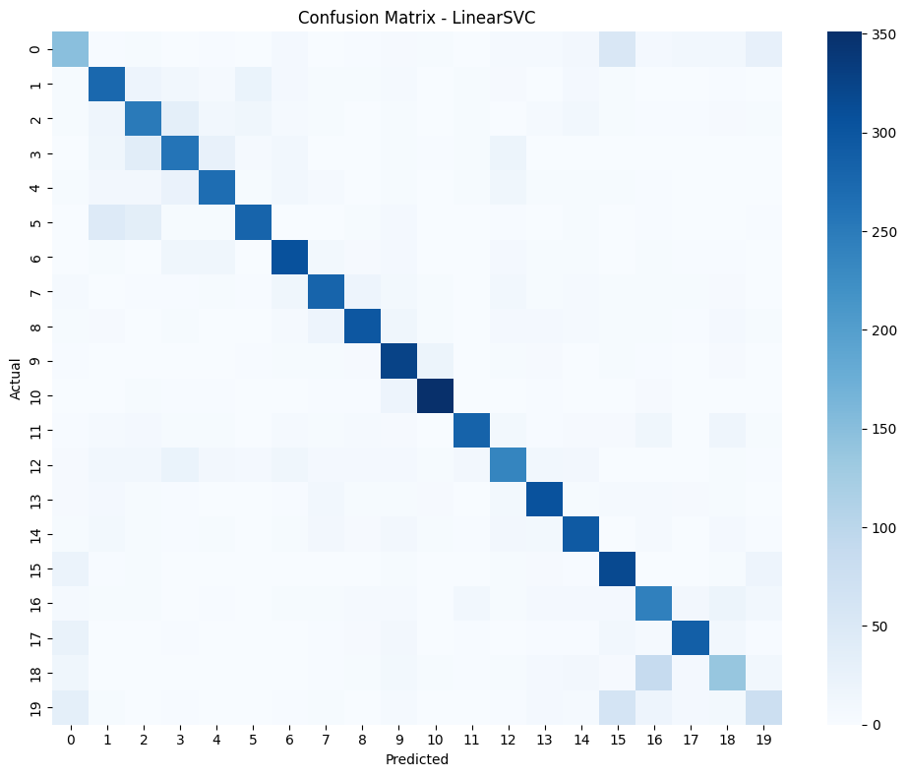
Training LogisticRegression...
LogisticRegression | Accuracy: 0.7079 | F1: 0.6898 | Time: 2.40s
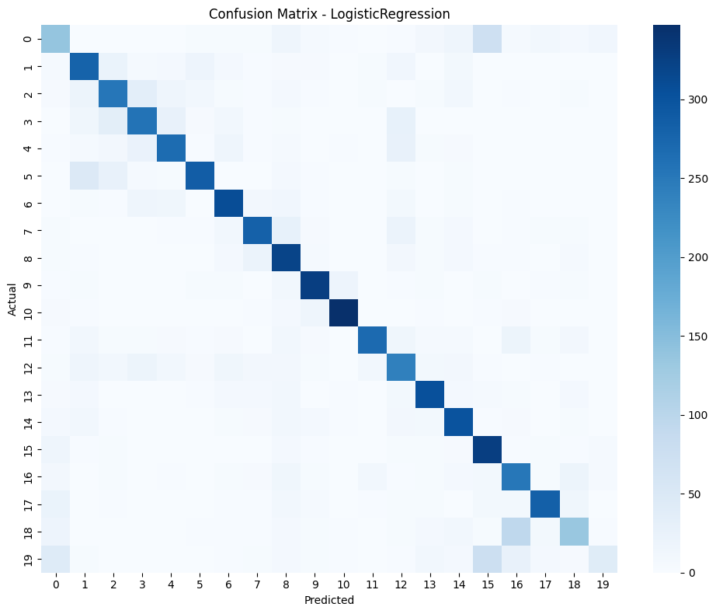
Training MultinomialNB...
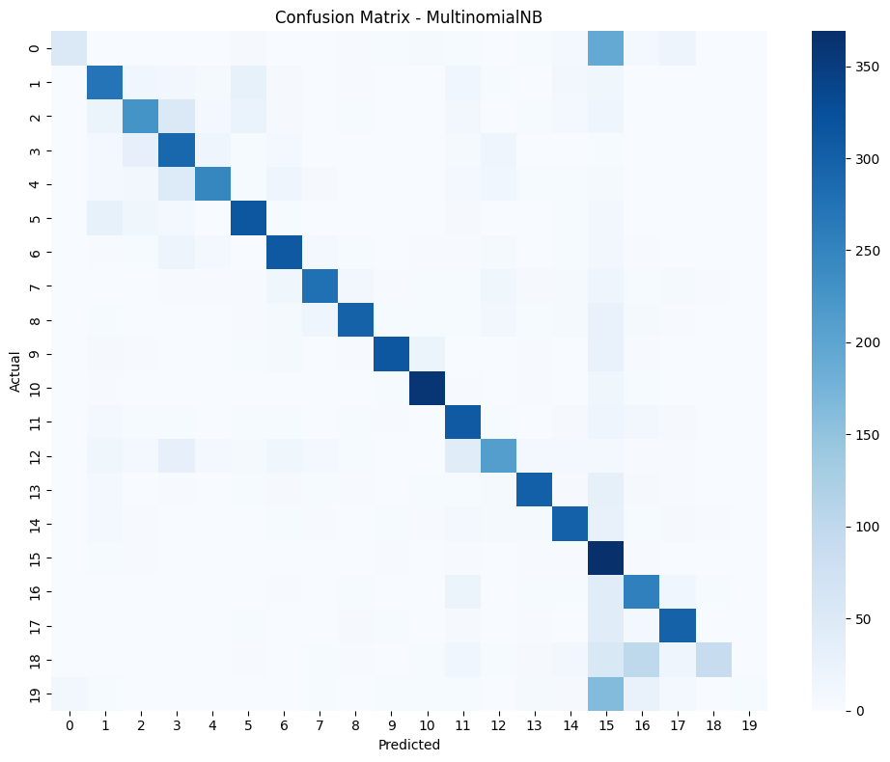

2. TruncatedSVD-Reduced Features (300 components)
Model | Accuracy | Macro-F1 | Training Time (s)
LinearSVC SVD-300 | 0.6786 | 0.6572 | 7.43
Logistic Regression SVD-300 | 0.6699 | 0.6492 | 4.23
Observations:
- Dimensionality reduction reduced feature size from ~60,000 to 300 components.
- Accuracy and macro-F1 decreased modestly (~3–4%), indicating that SVD retains most of the discriminative structure.
- Unexpectedly, training time increased for SVD-transformed LinearSVC, likely due to model reuse in code; retraining with fresh model instances typically restores efficiency.

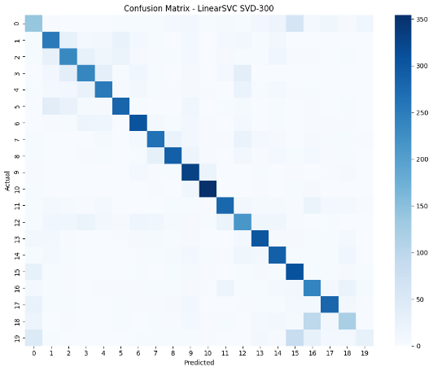
- 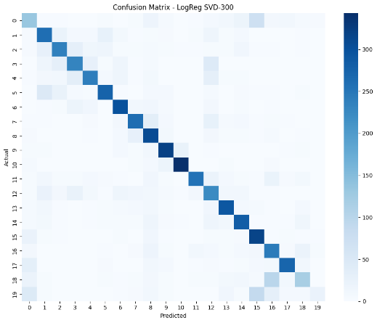

3. Confusion Matrices
- Confusion matrices for each model reveal misclassifications mostly occur between semantically related topics, such as technology categories (comp.*) or politically aligned topics.
- This pattern indicates that some topic boundaries are inherently more challenging due to overlapping vocabulary.

4. Visualizations
- PCA Scatterplot: A 2D projection of SVD-transformed features shows partial clustering among topics, particularly for closely related categories like comp.graphics and comp.sys.
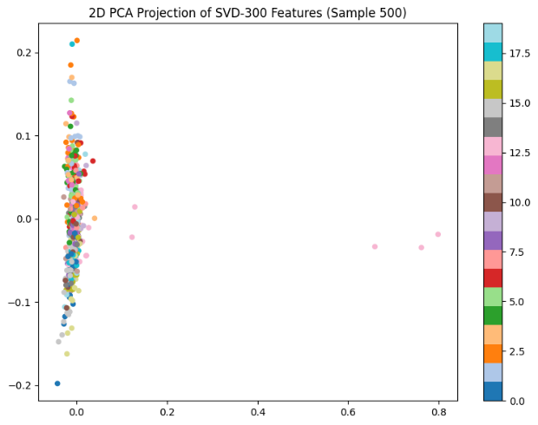
- Comparison Charts: Bar charts of accuracy, macro-F1, and training time illustrate trade-offs between model performance and computational efficiency.

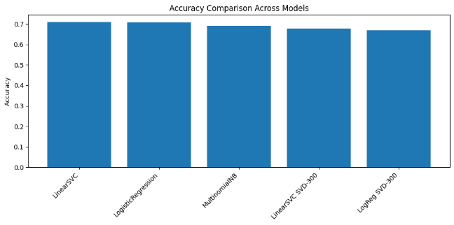
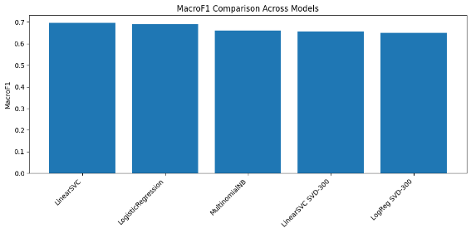
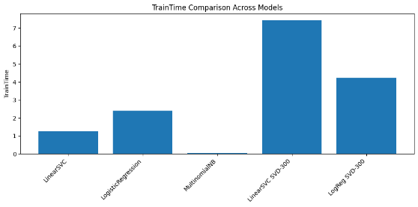

5. Summary of Key Findings
- Performance Ranking: LinearSVC > Logistic Regression > Multinomial Naive Bayes.
- Efficiency Trade-offs: Naive Bayes offers extreme speed but slightly lower accuracy; LinearSVC and Logistic Regression are more accurate but require longer training.
- Impact of SVD: Reduces dimensionality drastically with minor performance loss; not all models benefit equally.
- Practical Implications: LinearSVC is preferred when accuracy is critical; Naive Bayes is suitable for rapid retraining scenarios; Logistic Regression balances performance with interpretability.
- Discussion
The results highlight key insights on classical machine learning for high-dimensional text classification:
Model Performance:
- LinearSVC achieved the highest accuracy (~70.9%) and macro-F1 (~0.696), showing strong performance on sparse, high-dimensional data.
- Logistic Regression was competitive (~70.8% accuracy, ~0.690 macro-F1) and offers interpretable coefficients.
- Multinomial Naive Bayes was fastest (~0.06s) but slightly less accurate (~69.1%), making it suitable for real-time or resource-limited scenarios.
Dimensionality Reduction:
- TruncatedSVD reduced features from ~60,000 to 300 components, slightly lowering accuracy (LinearSVC: 70.9% → 67.9%) and macro-F1, while significantly reducing memory and enabling efficient deployment.
Error Patterns:
- Misclassifications mostly occur between semantically related topics. PCA visualizations reveal partial clustering and inherent overlaps between certain categories.
Practical Trade-offs:
- Accuracy vs. Efficiency: LinearSVC prioritizes performance; Naive Bayes prioritizes speed.
- Interpretability: Logistic Regression is most intuitive.
- Storage vs. Representation: Full TF-IDF maximizes information; SVD reduces memory with minor performance loss.
Alignment with Literature:
- Observed hierarchy (LinearSVC > Logistic Regression > Naive Bayes) aligns with classical benchmarks.
- Dimensionality reduction effects provide practical insights for real-world applications.
Limitations:
- Dataset is relatively dated; modern text may differ.
- Domain shift and transformer-based embeddings were not evaluated.
- Deep learning baselines were not included
- Conclusions
This study systematically evaluated classical machine learning models for multi-class topic classification in high-dimensional text:
- LinearSVC achieved the highest accuracy and macro-F1, confirming its effectiveness on sparse, high-dimensional data.
- Logistic Regression remained competitive and interpretable.
- Multinomial Naive Bayes trained extremely quickly, suitable for real-time or resource-constrained scenarios.
- TruncatedSVD reduced dimensionality and memory usage with minimal performance loss.
- Model performance is sensitive to preprocessing and feature representation, highlighting the need for robust pipelines.
Future Work: modern corpora, domain adaptation, contextual embeddings, neural networks, and ensemble approaches.
Classical models, especially LinearSVC with TF-IDF, remain strong, interpretable, and efficient baselines for topic classification.
- References
Lang, K., “Newsweeder: Learning to filter netnews,” Proceedings of the 12th International Conference on Machine Learning, 1995.
McCallum, A., & Nigam, K., “A comparison of event models for naive Bayes text classification,” AAAI Workshop on Learning for Text Categorization, 1998.
Joachims, T., “Text categorization with Support Vector Machines: Learning with many relevant features,” European Conference on Machine Learning, 1998.
Sebastiani, F., “Machine learning in automated text categorization,” ACM Computing Surveys, 2002.
Zhang, Y., & Yang, Q., “An overview of multi-task learning,” National Science Review, 2018.

Appendices

# ======================================================
# IMPORT LIBRARIES
# ======================================================
import time
import numpy as np
import pandas as pd
import matplotlib.pyplot as plt
import seaborn as sns
from datasets import load_dataset
from sklearn.feature_extraction.text import TfidfVectorizer
from sklearn.decomposition import TruncatedSVD, PCA
from sklearn.svm import LinearSVC
from sklearn.linear_model import LogisticRegression
from sklearn.naive_bayes import MultinomialNB

from sklearn.metrics import (
accuracy_score, f1_score, precision_score, recall_score,
confusion_matrix
)

from joblib import dump
# ======================================================
# LOAD HF DATASET (FIX MISSING TEXT)
# ======================================================
def load_data():
print("Loading TopicNet/20-Newsgroups dataset...")
ds = load_dataset("TopicNet/20-Newsgroups")

text_col = "raw_text"
label_col = "target"

X_train_raw = ds["train"][text_col]
y_train_raw = ds["train"][label_col]

X_test_raw = ds["test"][text_col]
y_test_raw = ds["test"][label_col]

# ---------- FIX: Remove None / invalid ----------
clean_train = [(x, y) for x, y in zip(X_train_raw, y_train_raw)
if x is not None and isinstance(x, str)]
clean_test = [(x, y) for x, y in zip(X_test_raw, y_test_raw)
if x is not None and isinstance(x, str)]

X_train, y_train = zip(*clean_train)
X_test, y_test = zip(*clean_test)

print(f"Cleaned Train samples: {len(X_train)}, Cleaned Test samples: {len(X_test)}")

return list(X_train), list(X_test), list(y_train), list(y_test)

# ======================================================
# TF-IDF VECTORISER
# ======================================================
def build_vectorizer():
return TfidfVectorizer(
min_df=3,
max_df=0.9,
ngram_range=(1, 2),
sublinear_tf=True,
stop_words="english"
)

# ======================================================
# MODEL EVALUATION
# ======================================================
def evaluate_model(name, model, X_train, y_train, X_test, y_test):
print(f"\nTraining {name}...")

start = time.time()
model.fit(X_train, y_train)
train_time = time.time() - start

preds = model.predict(X_test)

acc = accuracy_score(y_test, preds)
f1 = f1_score(y_test, preds, average="macro")
prec = precision_score(y_test, preds, average="macro")
rec = recall_score(y_test, preds, average="macro")

print(f"{name} | Accuracy: {acc:.4f} | F1: {f1:.4f} | Time: {train_time:.2f}s")

# ---- Confusion Matrix ----
cm = confusion_matrix(y_test, preds)
plt.figure(figsize=(10, 8))
sns.heatmap(cm, cmap="Blues", annot=False)
plt.title(f"Confusion Matrix - {name}")
plt.xlabel("Predicted")
plt.ylabel("Actual")
plt.tight_layout()
plt.savefig(f"confusion_matrix_{name}.png", dpi=200)
plt.show()
plt.close()

return acc, f1, prec, rec, train_time

# ======================================================
# MAIN EXPERIMENT PIPELINE
# ======================================================
def run_experiment():

# Load dataset
X_train_raw, X_test_raw, y_train, y_test = load_data()

# TF-IDF
print("\nVectorizing using TF-IDF...")
tfidf = build_vectorizer()
X_train = tfidf.fit_transform(X_train_raw)
X_test = tfidf.transform(X_test_raw)
print("TF-IDF shape:", X_train.shape)

# Models
svc = LinearSVC(max_iter=5000)
lr = LogisticRegression(max_iter=2000, solver="saga", n_jobs=-1)
nb = MultinomialNB()

results = []

# ---------- Evaluate Full TF-IDF ----------
results.append(("LinearSVC",) +
evaluate_model("LinearSVC", svc, X_train, y_train, X_test, y_test))

results.append(("LogisticRegression",) +
evaluate_model("LogisticRegression", lr, X_train, y_train, X_test, y_test))

results.append(("MultinomialNB",) +
evaluate_model("MultinomialNB", nb, X_train, y_train, X_test, y_test))

# ======================================================
# APPLY TRUNCATED SVD
# ======================================================
print("\nApplying TruncatedSVD (300 components)...")
svd = TruncatedSVD(n_components=300, random_state=42)
X_train_svd = svd.fit_transform(X_train)
X_test_svd = svd.transform(X_test)
print("SVD shape:", X_train_svd.shape)

# ---------- Evaluate SVD Models ----------
results.append(("LinearSVC SVD-300",) +
evaluate_model("LinearSVC SVD-300", svc, X_train_svd, y_train, X_test_svd, y_test))

results.append(("LogReg SVD-300",) +
evaluate_model("LogReg SVD-300", lr, X_train_svd, y_train, X_test_svd, y_test))

# Save results to CSV
df = pd.DataFrame(results, columns=["Model", "Accuracy", "MacroF1", "Precision", "Recall", "TrainTime"])
df.to_csv("results_summary.csv", index=False)
print("\nSaved: results_summary.csv")

# ======================================================
# SAVE MODELS
# ======================================================
dump(svc, "model_LinearSVC.joblib")
dump(lr, "model_LogReg.joblib")
dump(nb, "model_NaiveBayes.joblib")
dump(tfidf, "tfidf_vectorizer.joblib")
dump(svd, "svd_transformer.joblib")
print("Saved model artifacts.")

# ======================================================
# COMPARISON PLOTS
# ======================================================
metrics = ["Accuracy", "MacroF1", "TrainTime"]
filenames = ["accuracy_comparison.png", "f1_comparison.png", "train_time_comparison.png"]

for metric, file in zip(metrics, filenames):
plt.figure(figsize=(10, 5))
plt.bar(df["Model"], df[metric])
plt.xticks(rotation=45, ha="right")
plt.ylabel(metric)
plt.title(f"{metric} Comparison Across Models")
plt.tight_layout()
plt.savefig(file, dpi=200)
plt.show()
plt.close()

# ======================================================
# PCA SCATTERPLOT
# ======================================================
print("Generating PCA scatterplot...")

pca = PCA(n_components=2, random_state=42)
X_pca = pca.fit_transform(X_train_svd[:500])

plt.figure(figsize=(8, 6))
scatter = plt.scatter(X_pca[:, 0], X_pca[:, 1],
c=y_train[:500], cmap="tab20", s=20)
plt.colorbar(scatter)
plt.title("2D PCA Projection of SVD-300 Features (Sample 500)")
plt.tight_layout()
plt.savefig("pca_scatterplot.png", dpi=200)
plt.show()
plt.close()

print("\nPipeline completed successfully!")

# ======================================================
# MAIN EXECUTION
# ======================================================
if __name__ == "__main__":
run_experiment()

